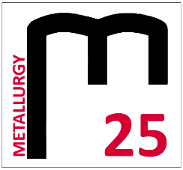
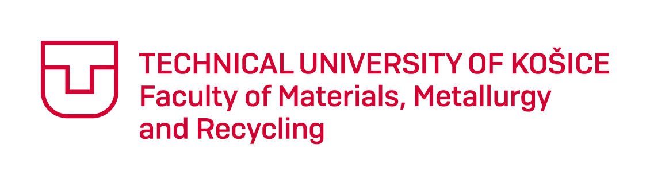

METALLURGY 2019

The Student´s Scientific Conference

11. 4. 2019 Košice
Registration form
Name:
University and year of study:
Address:
E-mail:
Title of contribution:
Section:
Accommodation: | 10.4. / 11.4.  Yes / No* | 11.4. / 12.4.  Yes / No*
Breakfast: | 11.4.  Yes / No* | 12.4  Yes / No*
Comment:

The participant of the student´s conference Metallurgy 2019 agrees that his or her name, surname, degree program, university or institute and photographs of the event may be published in electronic or printed form. Category winners agree to publish the above mentioned data.
Yes / No*
* Delete as appropriate

Registration form send to email: maria.hezelova@tuke.sk till 15.3.2019

