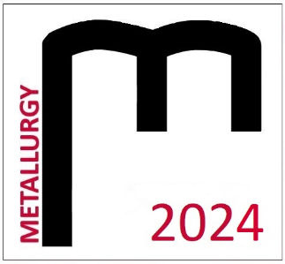

THE STUDENT´S SCIENTIFIC CONFERENCE

METALLURGY 2024
10 April 2024
Registration form

Name:
University
and year of study:
Address:
E-mail:
Title of contribution:
Section:
Accommodation 9.4.2024  Price €24.00 + €2.50  Paid by participant | Yes / No*
Breakfast 10.4.2024  Price approx. €6.00  Paid by participant | Yes / No*
Accommodation 10.4.2024  Price €24.00 + €2.50  Paid by participant | Yes / No*
Breakfast 11.4.2024  Price approx. €6.00  Paid by participant | Yes / No*

The participant of the student´s conference Metallurgy 2024 agrees that his or her name, surname, degree program, university, or institute, and photographs of the event may be published in electronic
or printed form. Category winners agree to publish the above-mentioned data.
Yes / No*
* Delete as appropriate

Please send the form by email to maria.hezelova@tuke.sk by 22.03.2024.

