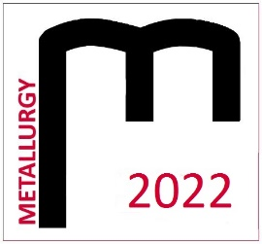
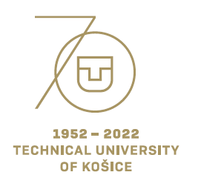

THE STUDENT´S SCIENTIFIC CONFERENCE

METALLURGY 2022
April 21, 2022

Registration form
Name:
University and year of study:
Address:
E-mail:
Title of contribution:
Section:
Comment:

The participant of the student´s conference Metallurgy 2022 agrees that his or her name, surname, degree program, university, or institute, and photographs of the event may be published in electronic
or printed form. Category winners agree to publish the above-mentioned data.
Yes / No*
* Delete as appropriate

Please send the form by email: maria.hezelova@tuke.sk by 25.3.2022.

