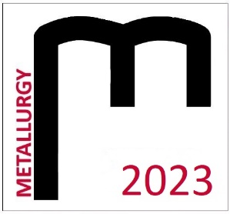

THE STUDENT´S SCIENTIFIC CONFERENCE

METALLURGY 2023
April 13, 2023
Registration form

Name:
University
and year of study:
Address:
E-mail:
Title of contribution:
Section:
Accommodation 12.4.2023  Price €22.00 + €2.50  Paid by participant | Yes / No*
Breakfast 13.4.2023  Price approx. €5.00  Paid by participant | Yes / No*
Accommodation 13.4.2023  Price €22.00 + €2.50  Paid by participant | Yes / No*
Breakfast 14.4.2023  Price approx. €5.00  Paid by participant | Yes / No*

The participant of the student´s conference Metallurgy 2022 agrees that his or her name, surname, degree program, university, or institute, and photographs of the event may be published in electronic
or printed form. Category winners agree to publish the above-mentioned data.
Yes / No*
* Delete as appropriate

Please send the form by email: maria.hezelova@tuke.sk by 27.03.2023.

