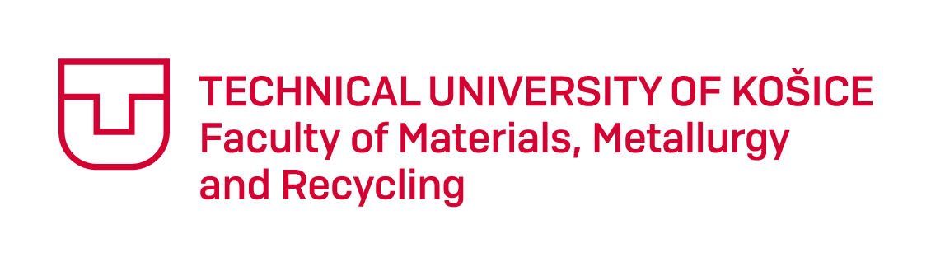

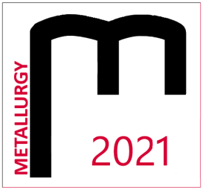
THE STUDENT´S SCIENTIFIC CONFERENCE

METALLURGY 2021

April 16, 2021, online conference

Registration form
Name:
University and year of study:
Address:
E-mail:
Title of contribution:
Section:
Comment:

The participant of the student´s conference Metallurgy 2021 agrees that his or her name, surname, degree program, university, or institute, and photographs of the event may be published in electronic
or printed form. Category winners agree to publish the above-mentioned data.
Yes / No*
* Delete as appropriate

Please send the form by email: maria.hezelova@tuke.sk by 26.3.2021.

